**Coffee Sales Analysis (USA)**

The data represents monthly coffee product sales of national coffee shop chain (fictional).

With the help of Tableau the below visualizations were made and analysis of the trends over the past year was made possible. This will in turn help take corrective measure if required.

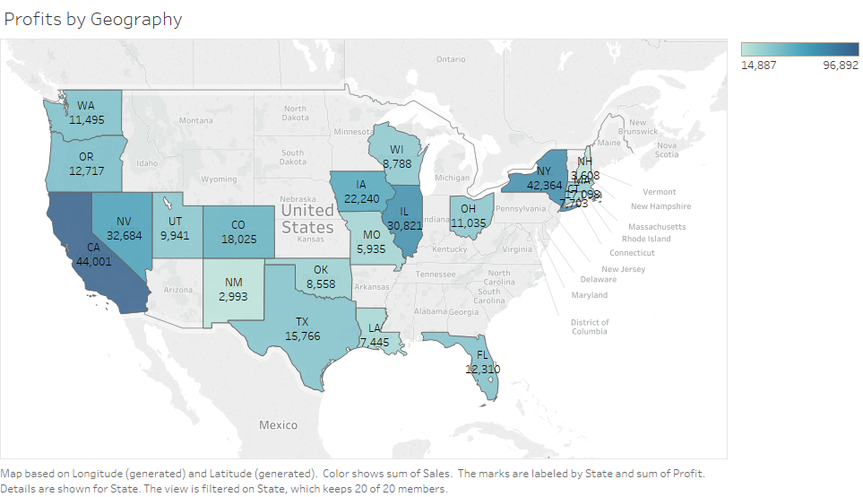

There is a strong correlation between the sales and the profits, it is evident from states like California and New York, when the profits are plotted for the geography. The contribution of Central and Western region are high which can be seen from the below graph.

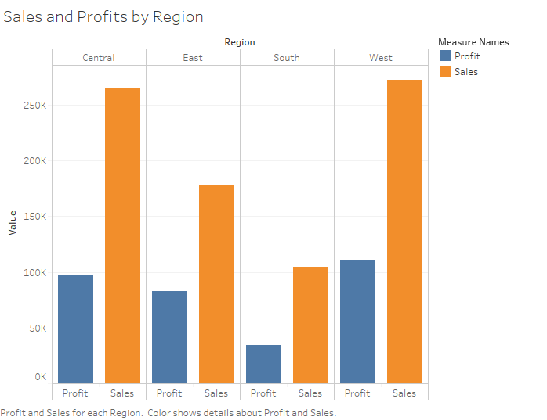

If we break the regions using Tree map we can see that CA and NY had the highest sales and profits in their respective regions.

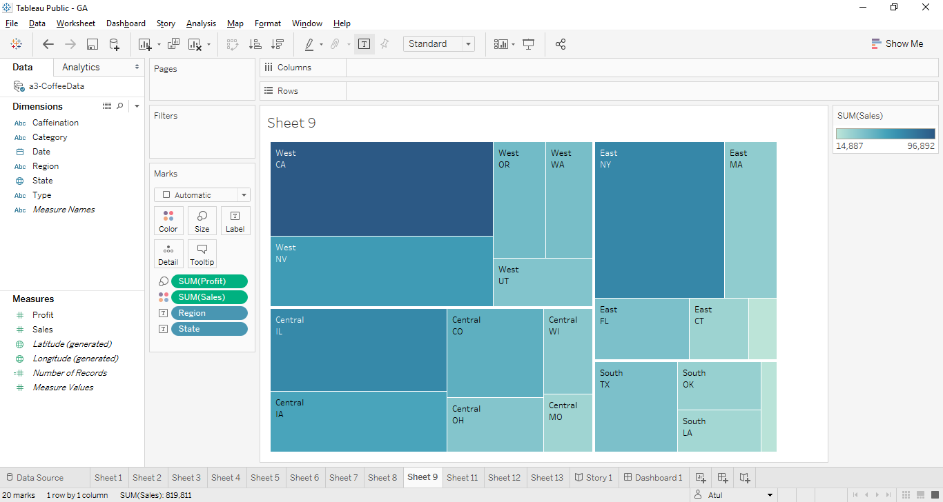

The correlation between sales and profit is again seen from this plot where Columbian and Green tree seem to dominate.

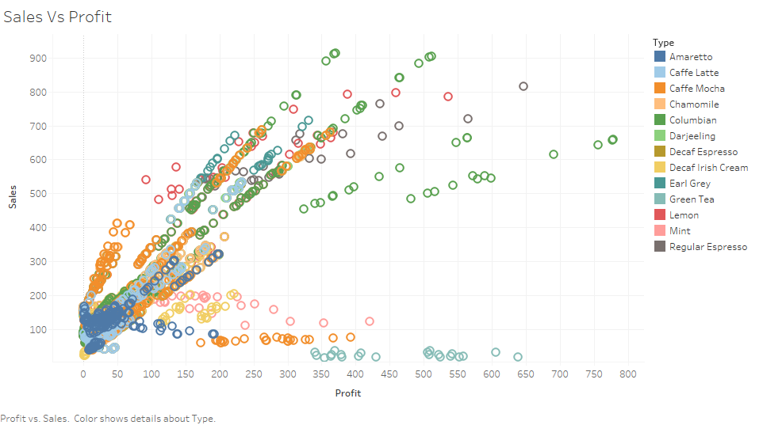

Also the below graphs depicts that Columbian coffee is major product of the company.

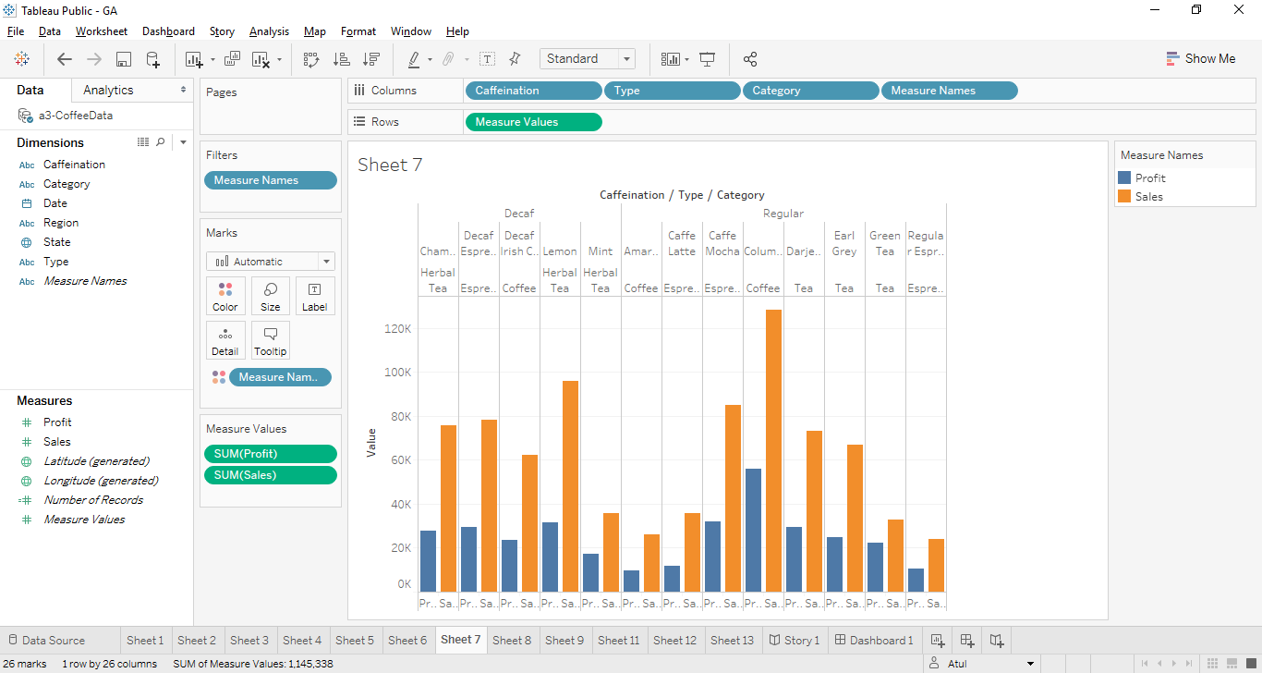

From the below graphs we can deduce that Profits have shown an increased trend from 2010 to 2011 even when there isn’t much difference in the sales.

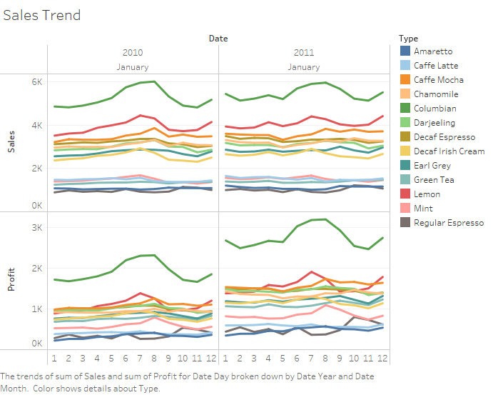

From the below two graphs we can see that Aug to Nov are the lean months in terms of sales.

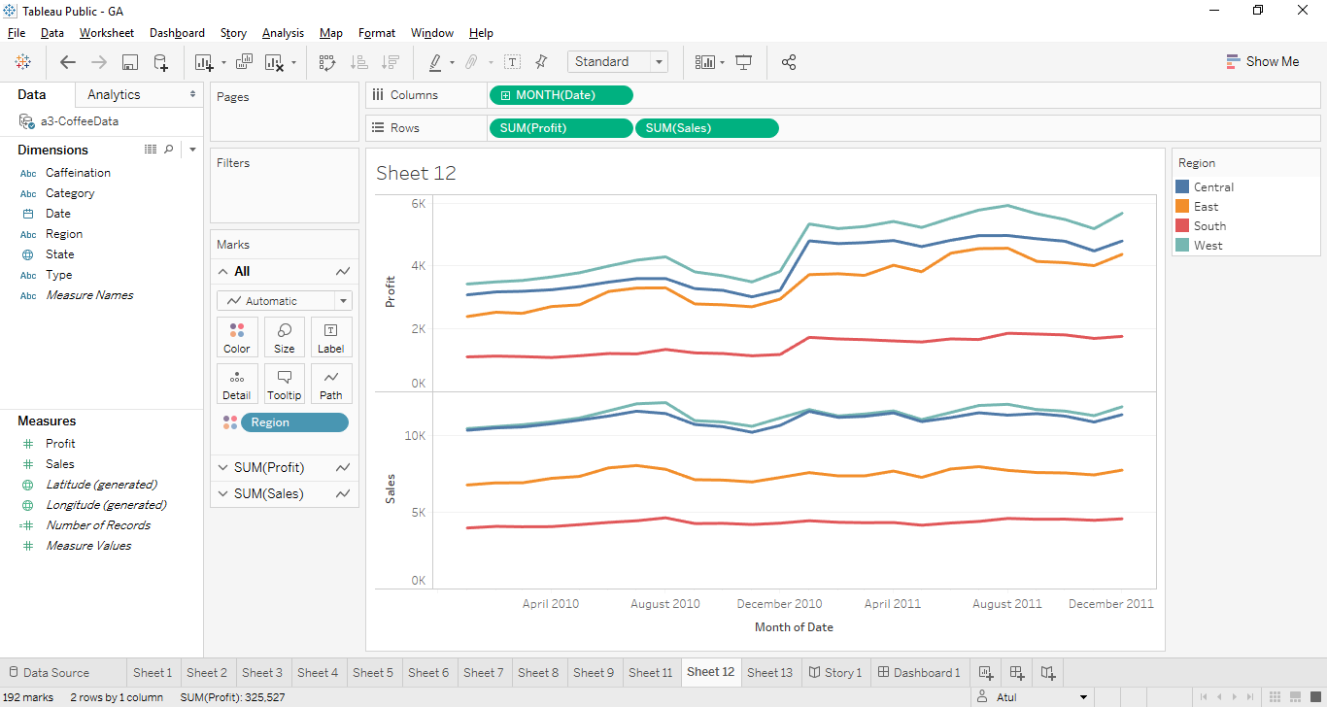

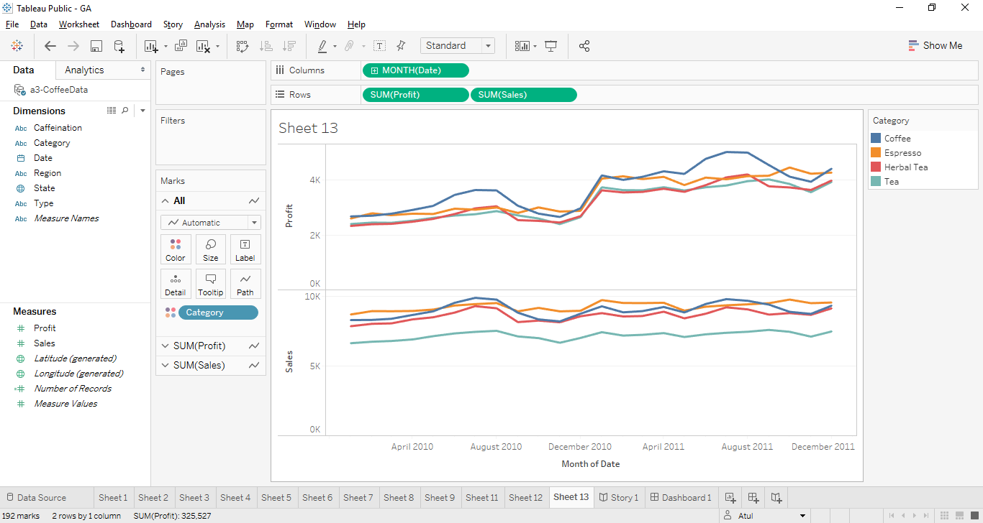

From the bar graph representation we could see that Columbian Coffee has been the highest contributor in terms of both sales and profit, which is also seen from the graph above which is the trend from 2010 to 2011. Sales of Espresso has been slightly higher with Regular caffeine being the preference of customers.

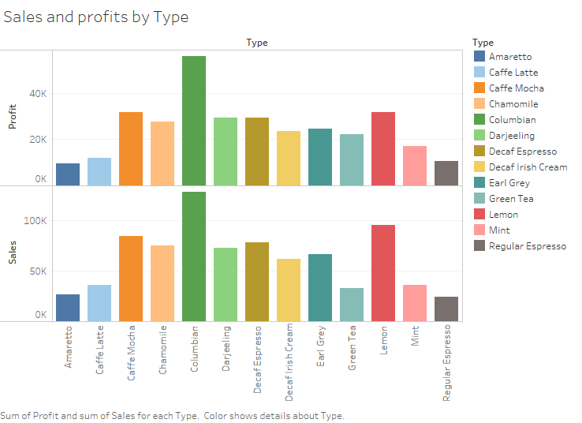

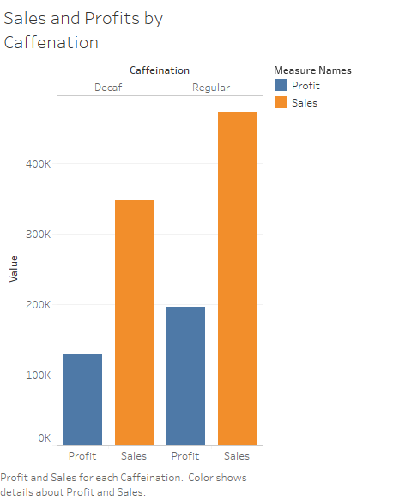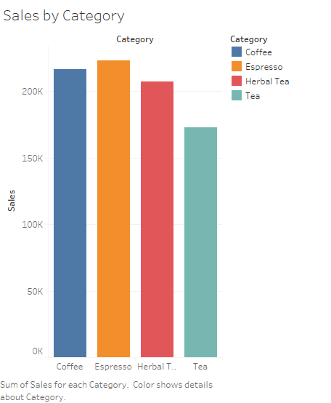

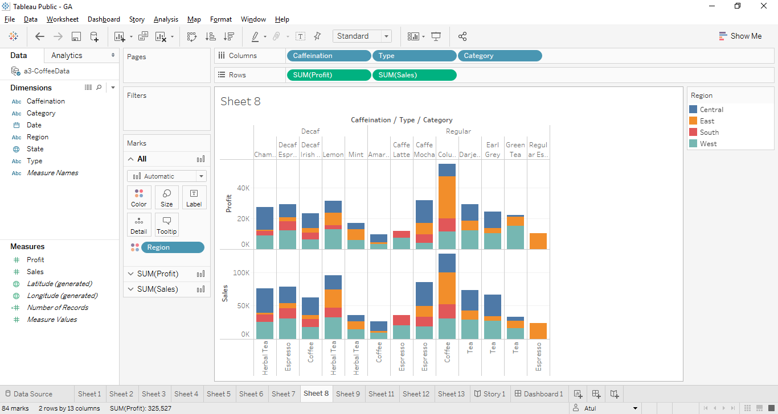

**Conclusion:**

* For the given data pre-processing was not required. Date format got automatically recognized in time format and also the state got recognized as Geographical location in Tableau
* We used different graphs to draw a story from the data.
  + i). We used histogram to get the best product for the company in form of profit and sales.
  + ii). We used stacked bars to see which region profit and sales were higher for a particular product line
  + iii). We used tree map to find out which state profit and sales were higher in a particular region.
  + iv). We made trend graph to check how the product category sales and profit decreased or increases with time.
* Sales in Central and West regions are high and subsequently are their profits.
* Sales of Regular Caffeine is high showing the preference of the consumers.
* Even when the sales haven’t increased much over the year but the profits have risen which is always a good sign of the success of the business strategy implemented.
* Both New York and California are doing well in terms of sales and profits, steps should be taken to boost sales in other states, which could be in terms of promotional offers or advertising campaigns. This will in turn boost profits the correlation is high between sales and profits of the dominating states.
* The visualizations helped to find lean months sales and high-density sales areas which help me to optimize my logistics and inventory cost.
* With Tableau it was very easy to prepare such complicated graphs which help to bring business outcomes which help in making proper decisions
* The trend graph of product category with time suggests that during the month from Aug to Nov the sales of these products fall. Might be due to summers during those months in the region.